March 11 2019 - 10:00PM
https://www.examiner.com.au/profile/200/sarah-aquilina
https://www.examiner.com.au/profile/747/matt-dennien

Crews battle Exeter blaze as investigations begin
https://www.examiner.com.au/story/5948287/crews-battle-exeter-blaze-as-investigations-begin/

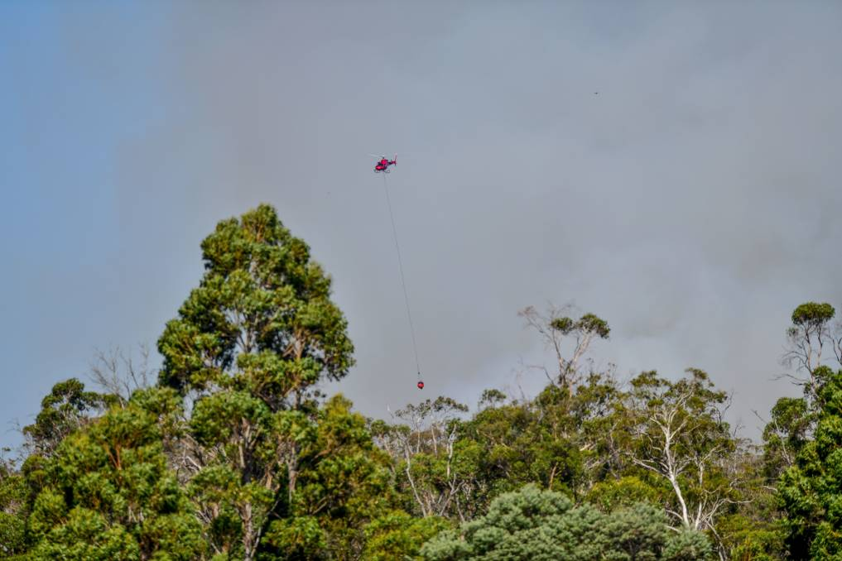
An advice level bushfire near Exeter continued to burn on Monday afternoon with 15 TFS vehicles, including helicopters, in attendance battling the blaze. Picture: Scott Gelston
Tasmania Fire Service is investigating the cause of a nine-hectare blaze at Exeter on Monday afternoon.
Crews from Legana, Gravelly Beach and Bridgenorth were still working from all sides to extinguish the blaze by Monday night, with two helicopters called in to assist with inaccessible areas.
Bulldozers were also being used to create firebreaks.
TFS issued advice for Lamena, Rosevears, Grindelwald, Bridgenorth, Legana and Notley Hills residents, with people told to check their bushfire survival plans and think about leaving if danger increased.
The blaze was between Long Plains Road and the West Tamar Highway, with lots of smoke and flames visible.
TFS said it could be difficult to control bushfires under the conditions, but there was no immediate threat to the community.7
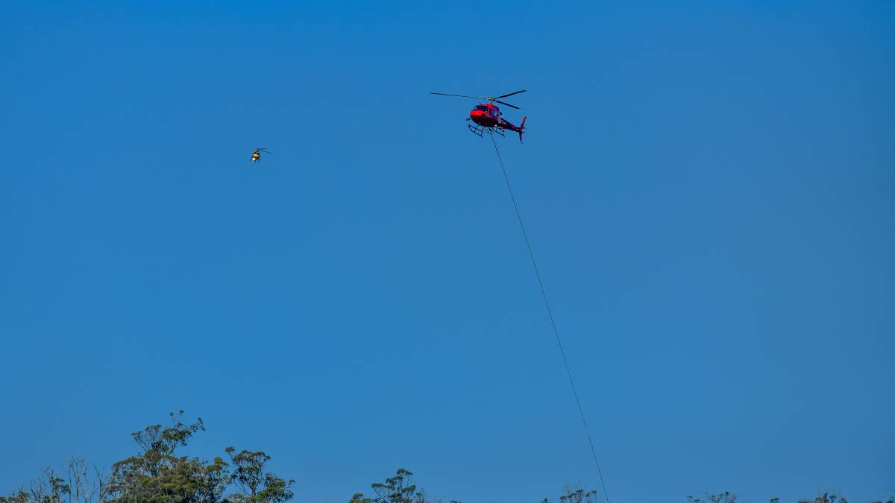

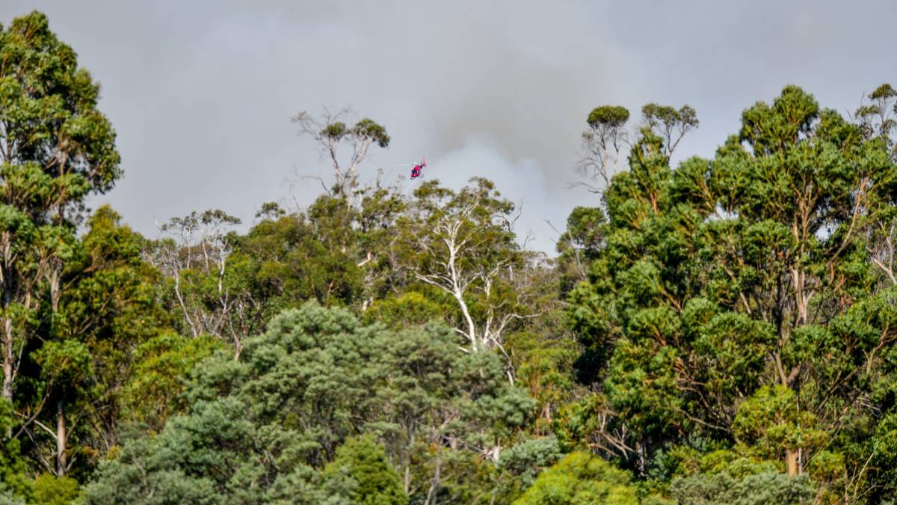

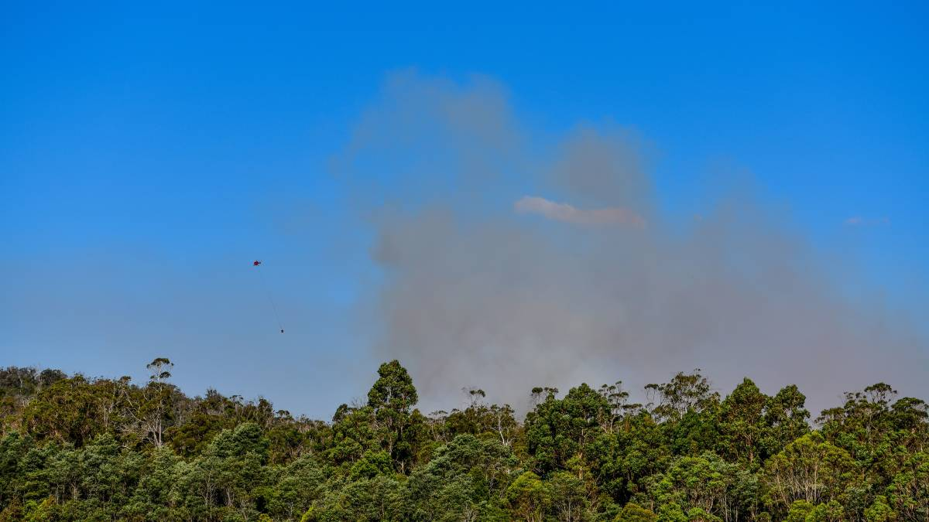

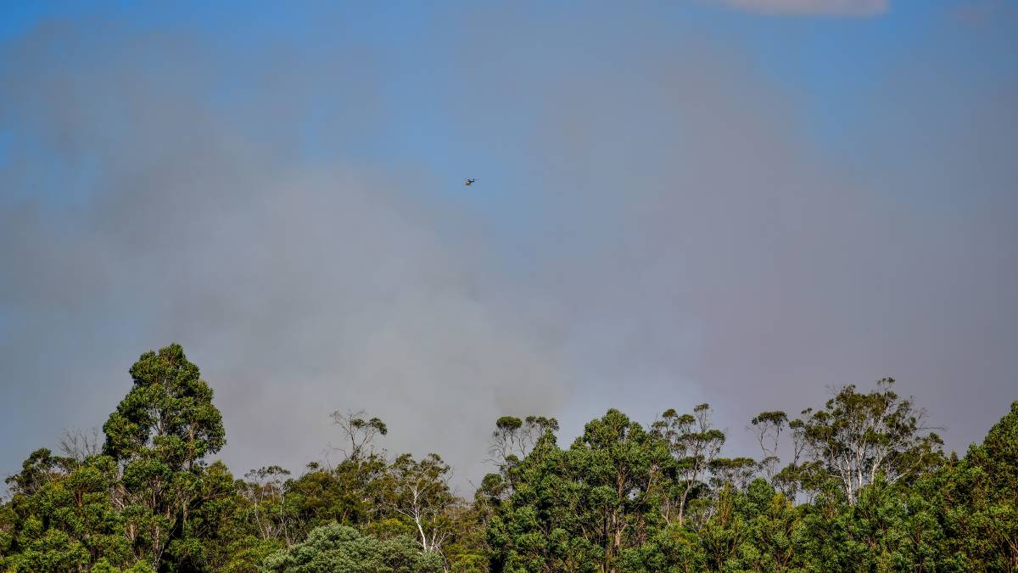

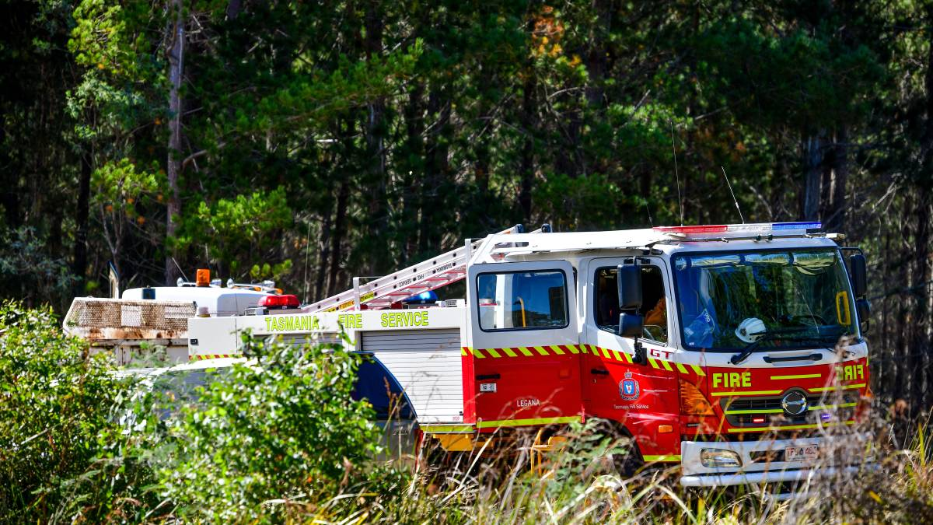
Scenes from the Exeterfire
Pictures: Scott Gelston
Police officers were called in to assist with traffic control.
The fire was burning close to a nearby plantation, though had not spread into it, with light northwesterly winds pushing it in the opposite direction.
The fire was burning close to a nearby plantation, though had not spread into it, with light northwesterly winds pushing it in the opposite direction.

